Task 1: Window Functions & Advanced Analytics

Task A (Ranking): Write a query to assign a rank to employees with highest salary based on their department
select employee_fname,salary,dept_id,
rank() over(
partition by dept_id
order by salary desc) as rank_based_on_salary
from employee;

Explanation:
This query assigns a rank to employees within each department based on their salary in descending order. The RANK() function with PARTITION BY dept_id ensures that ranking restarts for each department, so the highest-paid employee in each department gets rank 1.

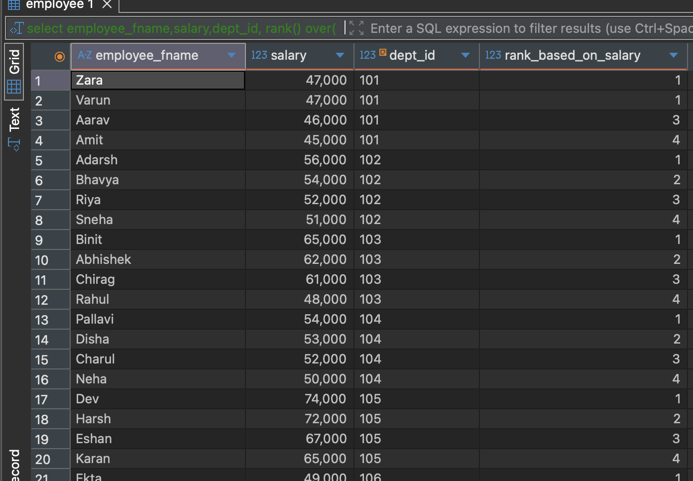

Task B (Running Total): specialized task to calculate the cumulative sum of salary each dept.

select distinct dept_name, dept_id, total_sal
from (
select d.dept_name,
d.dept_id,
sum(e.salary) over (partition by e.dept_id) as total_sal
from department d
join employee e
on e.dept_id = d.dept_id
) t;

Explanation:
This query calculates the cumulative salary for each department using the SUM() window function with PARTITION BY e.dept_id. It joins employee and department tables to show each department’s total salary alongside its name and ID.

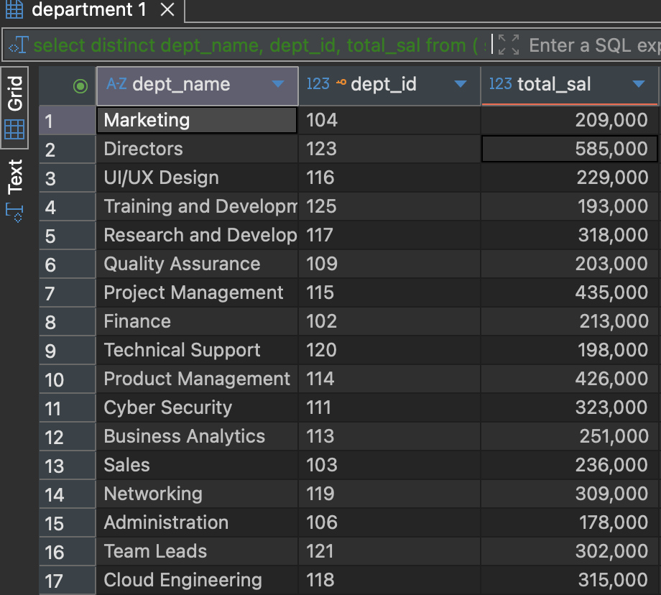

Task C (Lead/Lag): Display each employee’s salary along side his/her previous employee’s salary.

select employee_fname,salary,
lag(salary) over() as prev_salary,
lead(salary) over() as next_salary
from employee;

Explanation:
This query displays each employee’s salary along with the salary of the previous and next employee using LAG() and LEAD() window functions. It helps compare an employee’s salary to their neighboring records in the result set.
